**Assignment Topic: WatchMe**

# **Aim**

To design a social media app named “WatchMe” for mobile devices using flutter through which users can make posts, message, and react to other users and their posts.

# **Objectives**

* Search for similar apps in the market and understand how they work.
* Use flutter to design the necessary pages and layouts for the app maintaining the standards.
* Use flutter to make the pages and layouts workable.
* Make API for the application using node.js and MongoDB.
* Connect the API with the application.
* Add extra features than the similar applications available in the market.
* Test the app with some users.

# **Descriptions**

“WatchMe” is a social media platform through which people will be able to interact with each other’s and watch what are they doing through their posts. Users will have to register their details and then they can log in. Users can add and edit extra details anytime they are logged in. Users can make posts, like and comment on other users’ posts, tag friends, save posts, watch other users. Users will also receive notifications of other users’ react to their posts. Users can report posts, block and restrict other users.

# **Prototypes**

## **Home Page**

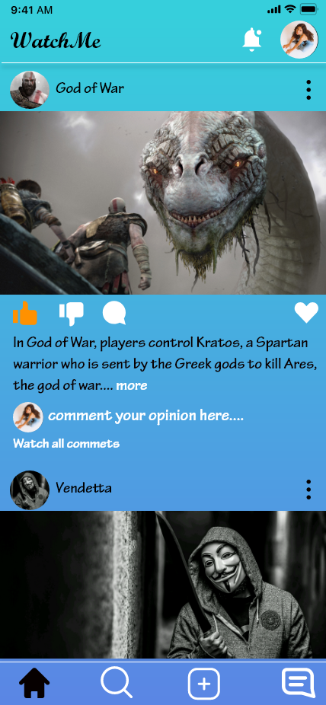

## **Search Page**

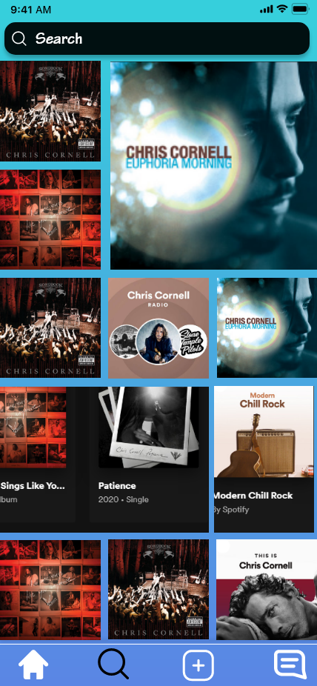

## **Message Page**

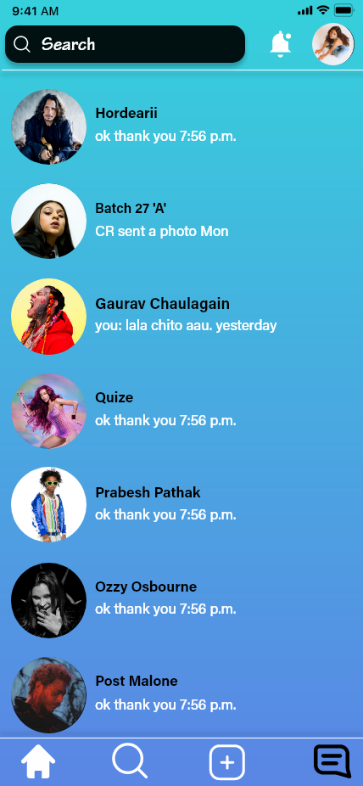

## **Notification Page**

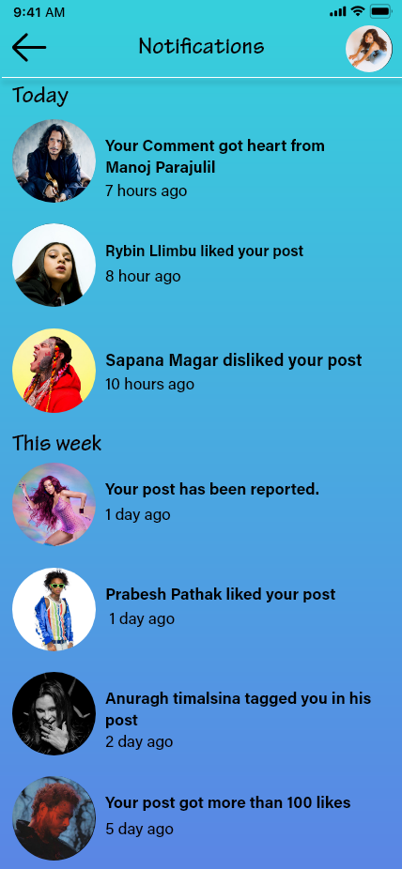

## **Profile Page**

